**Experiment No : 2(a)**

**Name : Mohammad Sohail Shaikh A56**

**Code: Write a Python program to print the largest of three numbers.**

def find_largest(a, b, c):

"""

Finds the largest number among three numbers.

:param a: First number (float)

:param b: Second number (float)

:param c: Third number (float)

:return: Largest number (float)

"""

largest = max(a, b, c) # Using the built-in max function

return largest

# Example usage

num1 = float(input("Enter the first number: "))

num2 = float(input("Enter the second number: "))

num3 = float(input("Enter the third number: "))

largest_number = find_largest(num1, num2, num3)

print(f"The largest number is: {largest_number}")

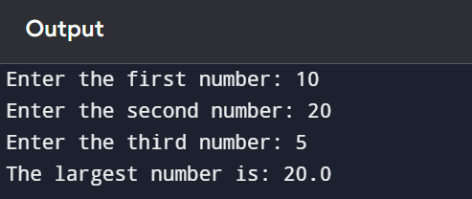

**2(b)**

**Code: write a python program to check whether a triangle is equilateral, isosceles, or scalene.**

def triangle_type(a, b, c):

"""

Determines the type of a triangle based on its side lengths.

:param a: Length of the first side (float)

:param b: Length of the second side (float)

:param c: Length of the third side (float)

:return: Type of triangle (str)

"""

if a == b == c:

return "Equilateral Triangle"

elif a == b or b == c or a == c:

return "Isosceles Triangle"

else:

return "Scalene Triangle"

# Example usage

side1 = float(input("Enter the first side: "))

side2 = float(input("Enter the second side: "))

side3 = float(input("Enter the third side: "))

triangle = triangle_type(side1, side2, side3)

print(f"The triangle is: {triangle}")

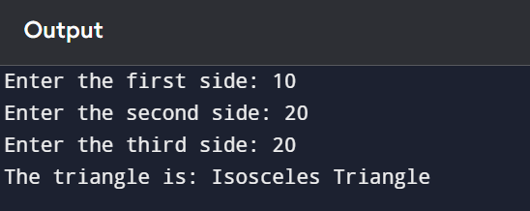

**2(c)**

**Code: write a python program to find the sum of the digits. (use while loop)**

# Take user input

num = int(input("Enter any number to find the sum of its digits: "))

# Initialize sum variable

s = 0

# Loop to extract and sum digits

while num > 0:

a = num % 10 # Extract the last digit

s = s + a # Add the digit to sum

num = num // 10 # Remove the last digit

# Print the sum of digits

print("Sum of digits:", s)

